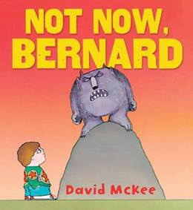
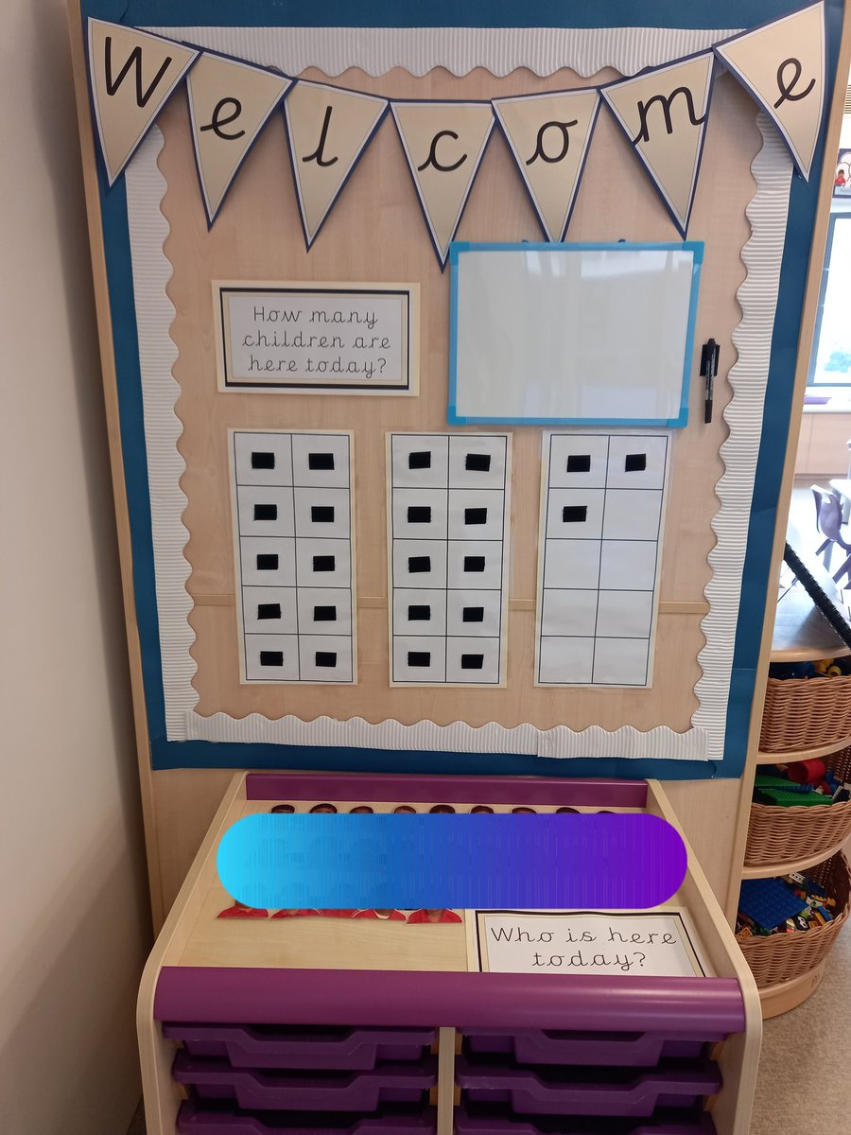
Home Learning
-Collect natural objects whilst out on an Autumn walk.
-Write your name for a purpose, for example, in a card.
-Play turn taking games.
Sharing Learning
Please do share any ‘wow’ moments of learning or key events in your child’s life with us at school. You can send in photos or e-mail them to adminoffice@vigo.hants.sch.uk and your child can tell their classmates all about it.
Expressive Art and Design
- Using shapes to represent (in models and in drawings).
- Exploring self-portraits (using loose parts, looking at artists and creating own versions).
- Holding and using a paintbrush.
- Exploring joining techniques at the junk bar.
Understanding the World
- Getting to know the classroom and school environment.
- Making maps.
- Meeting the school community.
- School now and then.
- Learning about the seasons.
- Exploring the natural environment (muddy Mondays).
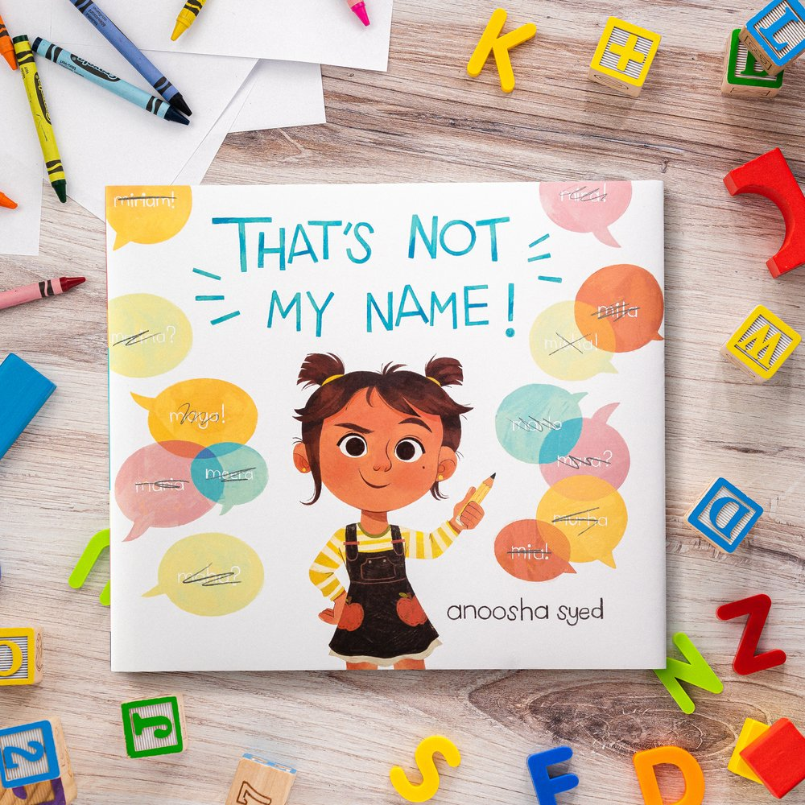
Year R Curriculum Overview – Autumn 1
Mathematical Development
- Self-registration.
- Then, now and next.
- Days of the week.
- Positional language such as next to, beside.
- Subitising.
- Using shapes for a purpose.
Physical Development
- Gross motor activities (rolling a ball, throwing and catching scarves etc).
- Building up our core strength – learning to sit in ‘Strong Gorilla’ for carpet times.
- Holding a pencil comfortably and using it to write our names.
Communication, Language and Literacy
- Talking – taking turns in a conversation.
- Phonics sessions (following the Read Write inc scheme).
- Voting for our favourite story.
- Learning new vocabulary related to life in school.
- Story themed activities – role-play and acting out well-known
stories.
- Writing labels and lists
(role-play parties, post
office etc).

Personal, Social and Emotional Development
- Getting to know our new friends.
- Working together – caring for our learning environment.
- Zones of Regulation.
- The Vigo High Five!
- Team games and
taking turns.
- Naming emotions.

