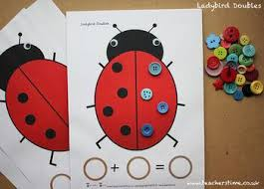
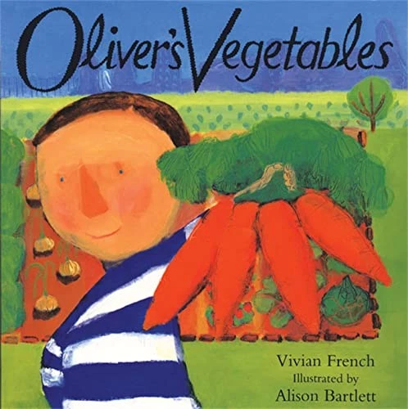
Home Learning
- Write a letter to someone in your family or to your favourite story character.
- Create your own game using a tally.
- Keep up your daily reading!
Sharing Learning
Please do share any ‘wow’ moments of learning or key events in your child’s life with us at school. You can send in photos or e-mail them to adminoffice@vigo.hants.sch.uk or via CLASS DOJO.
Expressive Art and Design
- Creating large scale works of Art using a range of techniques.
- Singing in a round (seaside shanties).
- Performing to others.
- Acting out stories using masks, props and puppets.
- Performing in a talent show to your friends!
Understanding the World
- Comparing Andover to other locations.
- Learning about a seaside location – what plants and animals live there?
- Investigations – for example into shadows and how they are created.
- Caring for our wonderful world (pollution).
- Growing vegetables.
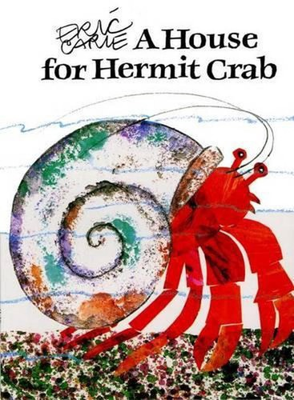
Year R Curriculum Overview – Summer 2
Mathematical Development
- Addition and subtraction problems.
- Number bonds to 10 and 20.
- Halving and doubling.
- Odd and even numbers.
Physical Development
- Working together to complete physical challenges (in our new house groups).
- Races (including Sports Day).
- Refining bat and ball skills and playing team games.
- Daily handwriting sessions – forming letters correctly.
Communication, Language and Literacy
- Stories themed around growing vegetables and different locations we might travel to on holiday.
- Using non-fiction books to find out facts.
- Re-telling well-known stories.
- Writing fact files
- and stories.
- Writing sentences,
including finger
spaces and full
stops.
Personal, Social and Emotional Development
- Celebrating children’s achievements through talent shows and sharing skills.
- Circle time – conflict resolutions.
- Transition events –
getting to know
your new class.
- Healthy lifestyles
Including tooth
brushing.

